Project title:
Enterprise Data Warehouse and Database Management Systems

Name: FAISAL KHAN DAHRI

Year: 2025

CONTENTS

INTRODUCTION 4
Task 1: Analytical Data Warehouse Design 5
Task 1.1: Defining Key Analytical Objectives 5
Task 1.2: Creating ER Diagram 6
Task 1.3: Creating Tables 8
Task 1.4: Creating Trigger 11
Task 2: Data Analytics using SQL 13
Task 2.1: Importing Data 13
Task 2.2: Solve The Analytical Objectives 16
Task 2.3: Creating a Store Procedure 22
Task 2.4: Chen Notation Diagram 24
Task 3: Theoretical Discussion 26
Task 3.1: Query Optimization 26
Task 3.2: ACID Properties 27
Task 3.3: CAP Theorem 28
Task 3.4: Case Study 29
CONCLUDING REMARKS 31
BIBLIOGRAPHY 32

INTRODUCTION

In this assignment we will make a database for an online shopping platform using MySQL.
Within the first chapter, we will define key analytical objectives that we will achieve using our database, we will formulate our Entity Relationship (ER) diagram, on the basis of which create our data base, normalize it, define data types, primary keys, foreign keys and insert triggers.
In the second chapter we will import data into our database, solve our analytical objective using SQL queries, create a store procedure and create an updated proposal for our database using Chen’s Notation diagram.
For the third chapter we will have a theoretical discussion where we will discuss a query which we wrote to solve our analytical objective, how we optimized the query and how larger data sets might impact the speed of this query.
We will define ACID properties and discuss its importance in our marketplace scenario. We will talk about the CAP theorem. And finally, we will discuss the case study of Amazon as an e-commerce business and talk about its infrastructure.

Task 1: Analytical Data Warehouse Design

Task 1.1: Defining Key Analytical Objectives

We will first of all establish our analytical objectives for our ‘Online Shopping Marketplace’ database which we will try to solve further on in this project.
Objectives:
- We will try to find out the customers purchasing behavior, we will attempt to determine the top five customers as per their highest spending on orders.
- Secondly, we will try to figure out which vendor produces the most revenue and what are their best-selling items.
- As per the third analytical objective we will analyze the correlation between product review and total revenue i-e do high rating mean high sales for that product or not.
- We will then calculate average product revenue based on customer ratings.
- We will rank products based on revenue and reviews using window function.
- Lastly, we will find the best-selling product category using set operations
But before we can come to our analytical objectives, we first need to create our database which we will call ‘Online Shopping Marketplace’, this relational database will be created using a relational database management system called MySQL, MySQL is a relational database management system (RDBMS). This is a modern way to store structured data within different tables and relating them through references called foreign key. SQL, Structure Query Language is used to access these databases. It will contain multiple columns comprising all the key details in relationship to our online business, we will normalize the schema and create relationships to the third normal form.
Structured data stored in tables it is possible to reference these tables across themselves such relationships lead the database being called relational database (Kofler, 2004).

Task 1.2: Creating ER Diagram

But before creating the database it is essential to create an Entity Relationship diagram for our database that will give us a blue print of the entire schema the relationship and help us all the way from creating the database and future understanding of it.
Below you will see the created ER Diagram:
Figure 1: ER Diagram for the Database
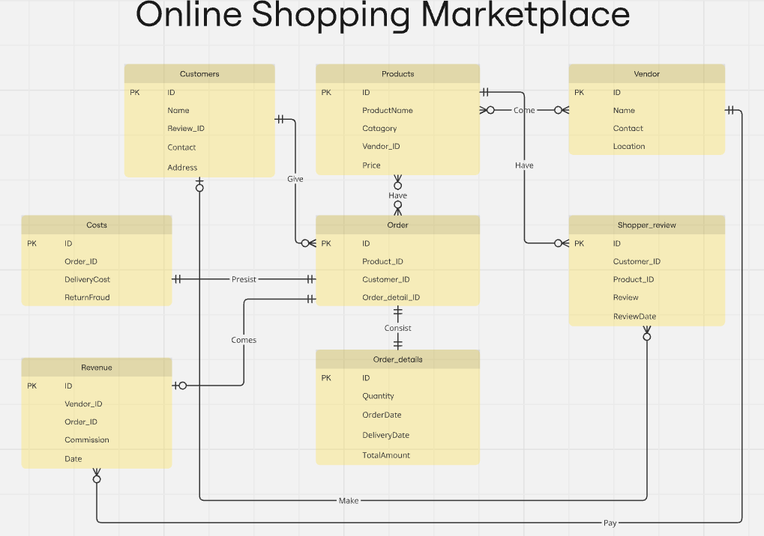
As in the ER diagram we can see that we have created 8 tables namely Products, Vendor, Customers, Order, Order Details, Shopper Reviews, Costs and Revenue.
Having a robust design will create a robust system, a common way of designing relational databases is entity relationship model (Mohammad et al., 2015).
In RDBMS we detach tables, this process is called ‘Normalization’, we do so with the key objective to increase the query processing speed, this normalization is done by creating foreign key constraints that connect a table with other tables as seen above in the ER Diagram.
Furthermore, we will try to explain our database structure in detail where primarily we have the Products table which contain the key details regarding the products their name, category, price and the vendor they have been catered by, as it can be seen the ‘Vendor ID’ is a foreign key constraint that connect this table with the Vendor table where we have key information on our 100 different vendors.
Then we have our customers table which have key information regarding the customers including their ‘Review ID’ which is a foreign key and connects the table to out ‘Shopper review’ table where customers reviews are store in relationship to the products they are reviewing, the review rates from 1 to 5 stars.
Then we have our ‘Orders’ table where the orders are saved as per the customer who ordered them and the products, they have ordered these both are foreign keys and we have another foreign key ‘Order details ID’ this relates to out ‘Order detail’ table which hold the information as to the order quantity, date, time of delivery and amount collected.
We have two other tables for ‘Costs’ that tell us the delivery cost, return fraud and in relation to the orders place the ‘order ID’ column relates this table to our orders table. And the last we have ‘Revenue’ table having the information of the commission we got from which vendor for which order and on which date. Hence, these will be our 8 tables comprising of all the information for our data base.
Foreign Keys are structuring constraints in a relational database, using these a set on column in one table is use to structure rows in another (Cleve and Hainaut, 2012).

Task 1.3: Creating Tables

Now we will try to create these tables on to our data base using MySQL. Below you will see screen shouts of our created tables and inserted foreign key.
Figure 2.1: Products Table
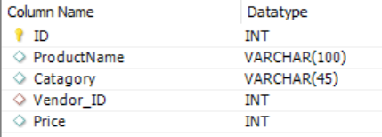
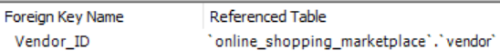

Figure 2.2: Customers Table
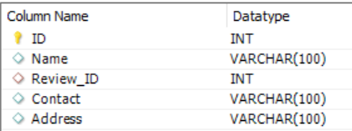

Figure 2.3: Vendor Table
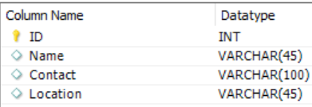

Figure 2.4: Orders Table
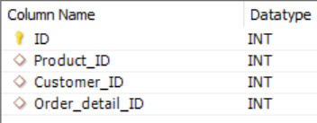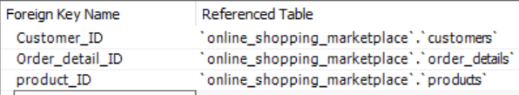

Figure 2.5: Order details Table
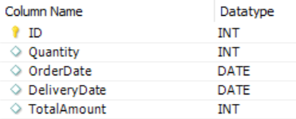

Figure 2.6: Shopper review Table
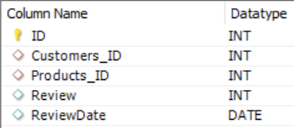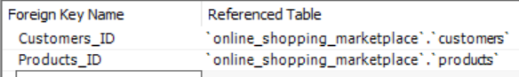

Figure 2.7: Costs Table
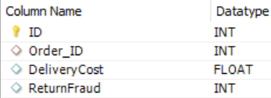
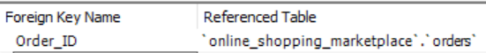
Figure 2.8: Revenue Table
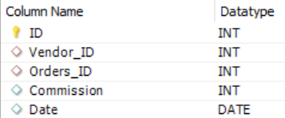
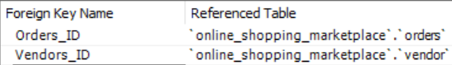

As you can see above, we have created all the columns for each of our tables in our data base “Online shopping market place”, giving them their required data format whether it be Integer, date, varchar, etc. and we also added the foreign key constraints.

Task 1.4: Creating Trigger

Moreover, we will set up a Trigger for our Shopper review table, triggers are used to perform checks in tables where they can perform automated calculations or stop certain values being inserted in certain columns, etc. We will add a trigger into our ‘Shopper review’ table, in the column ‘review’, this trigger will ensure that the required rating should be between 1 to 5 stars hence, any rating over this will not be registered hence, a rating of for example 6 will not be registered.
Figure 3: Trigger SQL Query
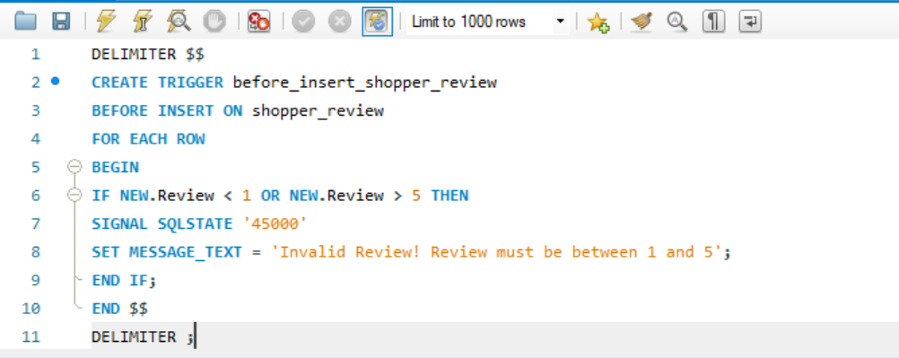
We have inserted the trigger where if the value in less that 1 or more that 5 it will not be inserted and an error will be shown. We shall now test whether our trigger works or not.
Figure 4: Trigger Testing
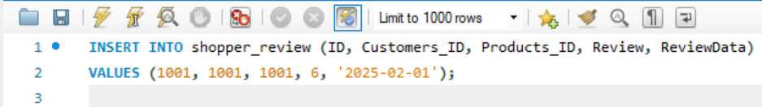
We tested our Trigger by inserting a review of 6 which failed to insert and an error showed up stating that the review is invalid hence, proving that our trigger works.
A trigger is a database procedure that automatically fires when trying to modify data in the table (Brock, 2023).

Figure 5: Schema Diagram/ Database Model
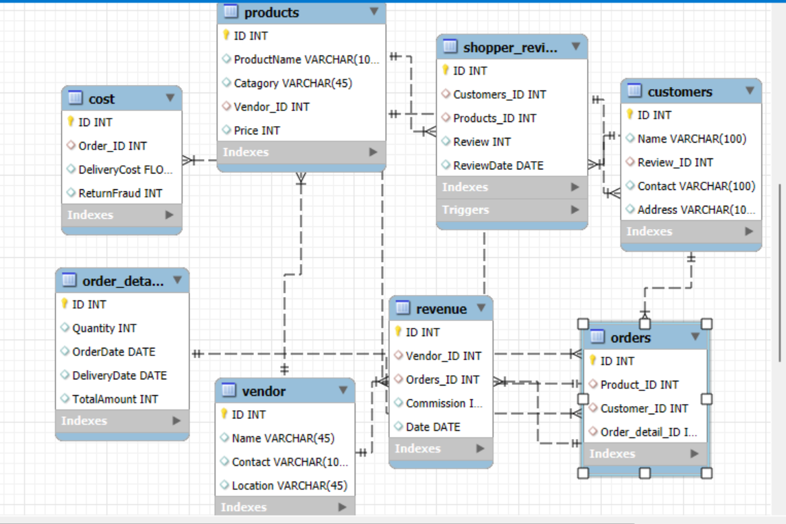

Task 2: Data Analytics using SQL

Task 2.1: Importing Data

We will now try to populate our database tables with dummy data so that we can perform our analysis of the objectives defined above. There are various ways to populate our tables, what we will cooperate today is try to use python to create dummy data for the ‘Products’ table and import it into our MySQL database table and for the rest of our tables we will try on a differ way to populate them which is by importing data through excel.
Figure 6: Populating Products table using Python
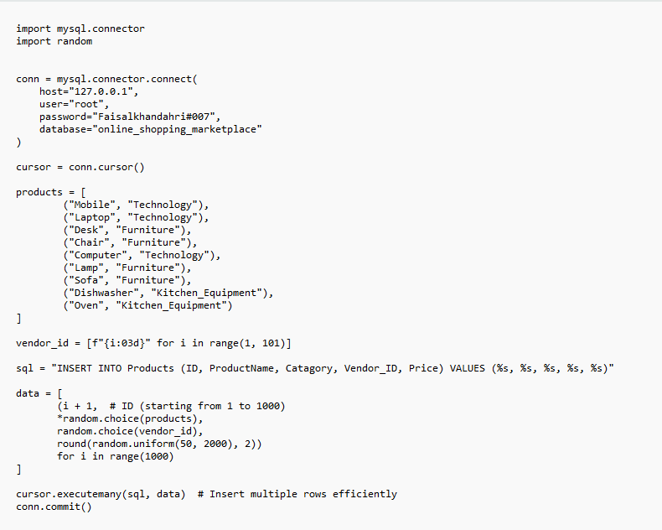
Here as you can see using python, we imported our MySQL connector and connected the python script our database using our MySQL login credentials. We named our products and the category they belong to, we set up our vendor id from 1 to 100 random numbers and gave the products prices.
Figure 7: Result of the Python code for Products Table
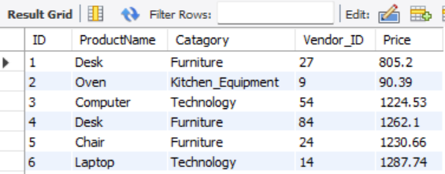

Furthermore, we successfully populated the rest of the 7 tables of our database by importing excel files.
Figure 8: Populating the rest of the tables
Costs Table
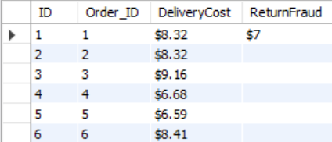
Revenue Table
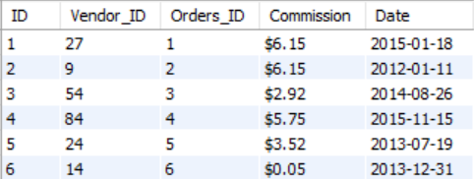

Customers Table
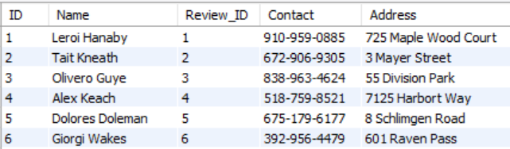
Orders Table
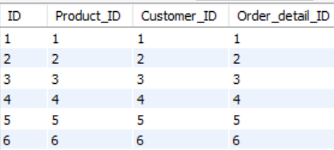

Orders Detail Table
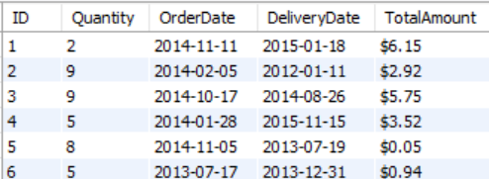
Shoppers Review Table
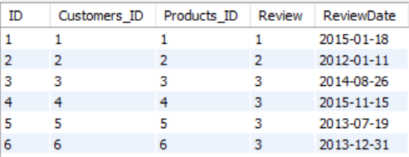

Vendor Table
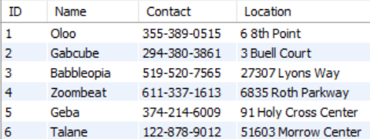

Furthermore, we will write SQL queries to address the analytical objectives we defined above. As as per the required task we will incorporate joins, filters, aggregations, operation with strings, set operations and window functions.
Structured Query Language (SQL) is the primary language used to communicate to relational databases (Rockoff, 2021).

Task 2.2: Solve The Analytical Objectives

Objective 1: Analyzing Customer Behavior
Hence, as per our primary task we will attempt to analyze customer purchasing behavior by finding out top five customer with the highest spendings. Below you will see the SQL query and the result of this analysis.
Figure 9: Analysis of Customer Purchasing Behavior/ Top 5 Customers
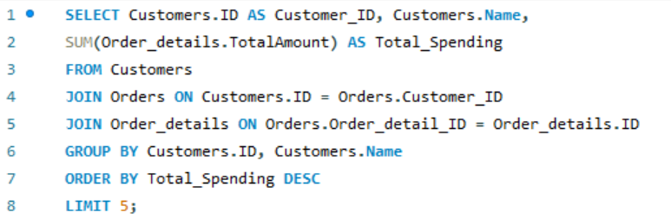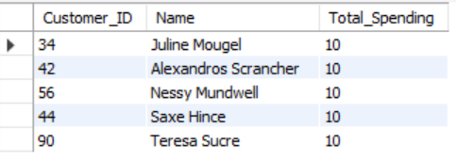
Here in this query as we can see we have summed up the total spending amount present in our order detail table and presented it with the customer id and name for this we had to use two join clauses to join our customers table with orders table and orders table with our order details table, then we took the summed up amount and grouped it by customer id and name and used the order by clause to order the finding in descending order (DESC) giving us the highest values first and limited our search by top 5. Hence, here we have used the “SELECT, JOIN, AS, GROUP BY, ORDER BY, LIMIT, SUM” queries.

Objective 2: Most Profitable Vendor
Furthermore, we will do an analysis to calculate the vendor whose products generate the highest revenue. Below you will see the SQL query and the results of this analysis.
Figure 10: Most Profitable Vendor
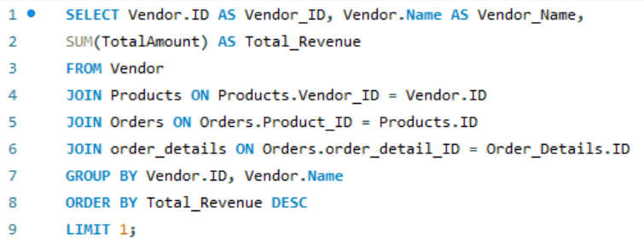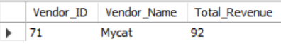
In the above SQL query, it can be seen that we have summed up the total amount from the ‘order details’ table joined it up with orders tables, orders table with products and products table with Vendor, then grouped the sum amount by Vendor ID and Vendor Name, we used the order by function to order the finding in descending order and limited the finding by 1 giving us the top most revenue collected. Here we have encompassed the ‘SELECT, SUM, JOIN, GROPUP BY, ORDER BY and LIMIT’ functions.

Objective 3: Top 3 Best Selling Products
Now we fill perform an analysis to find out the top 3 best selling products. Below you will see the SQL query and the results of this analysis.
Figure 11: Top 3 Best-selling Products
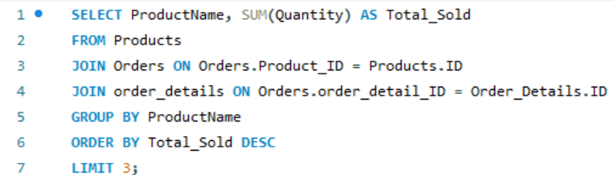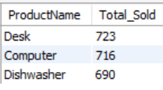
Here as we can see we have used the sum function to sum up the quantity, put in our joints to join the tables products to order and orders to order details and grouped them by product name, to give us the names of top best-selling products.

Objective 4: Average Products Revenue based on Customer Rating
Moreover, we will calculate the average revenue of products with high revenue i-e in between 4 and 5 and products with low rating in between 1 to 3. Below you will see the SQL query for this task and the results.
Figure 12: Average Revenue base on Customers Reviews
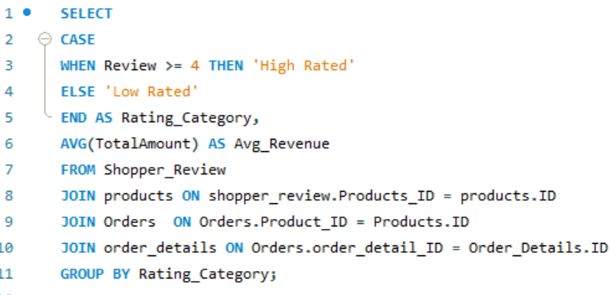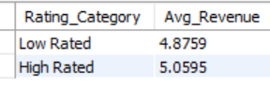
Here we have used a Case function which is used to put in a condition that help return the values we ask of it. We have used Case function to divide the reviews equal or above 4 to High rating and below 4 as low rating, we took the average of Total amount, place in the required join statement to connect our tables Shopper review to products, products to orders and orders to order details and got the above results show casing the average profits for high and low rated products.

Objective 5: Using Window Function to rank products based on revenue and rating
Under this task we will calculate the total revenue of each product, the average review of those products and their rank based on the revenue collected. For this we will be using a window function, a window function is used to perform calculations across multiple rows, here the rows are not collapsed or reduced but the number of rows remain the same. Below you will see the SQL query for this calculation and the result.
Figure 13: Ranking Products based on Revenue and Review
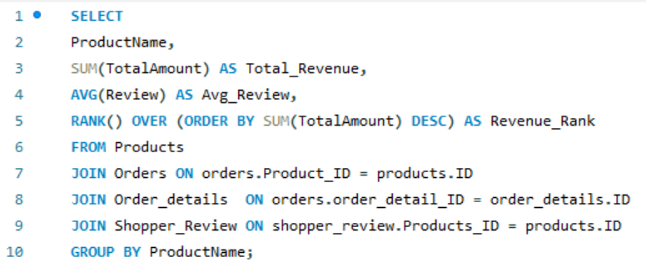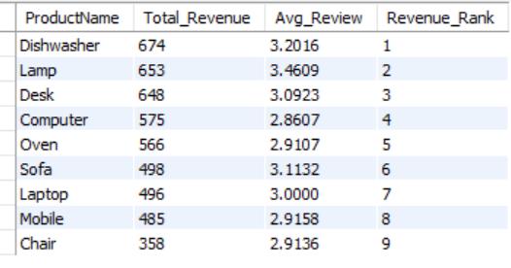
Here as it can be seen we have used the window function Rank () and Over () to arrange the rank of the products; the Order by function in side Over() clause this decides how the rank will be given. We have summed up the total amount took the average of reviews, placed the relevant join statement to join our table and got the following results that showcases the Products total revenue, average review and ranks them according to the product that collected the most revenue to the least.
Objective 6: Best Selling Category Using Set Operations
Under this task we will try to calculate the best-selling category, we will be using a set operation which are used to combine results from multiple set Select queries. The set operation we will be using is Union which is used to combine results from two queries removing any duplicates. Below you will see the SQL query to calculate best selling Category using UNION function and its result.
Figure 14: Best Selling Category
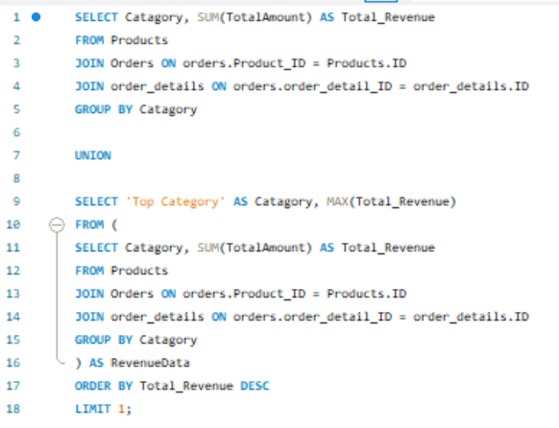
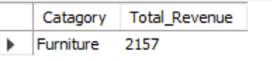
Although this query may have been written more simply to get the same results but for the sake of performing a set operation, Union function, we have written this query. Here we have two Select queries joined by a Union in the above one we have calculated the total revenue by category and in the second query we have used the Order by function to find the most profitable category and the Limit function to show case the number 1 bestselling Category.

Task 2.3: Creating a Store Procedure

We will try to create a store procedure for our database. A store procedure is a prepare and implement SQL code that saves you up time so that you don’t have to write the same code again and again but you can just call on to that store procedure and it will give you your pre encoded analysis. Below you will see our SQL query for a store procedure where we tried to make a procedure for calculating total revenue, total cost and total profits as per the respected dates.
Figure 15: Store Procedure Query
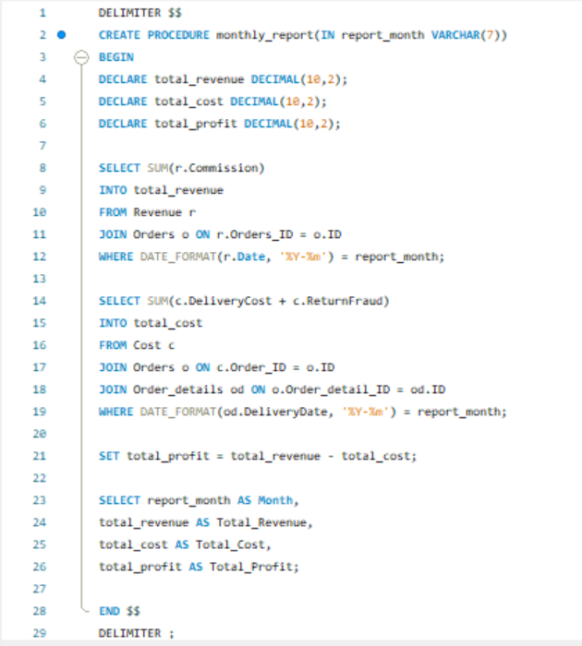
Here as you can see, we have Declare our desired columns to be total revenue, total cost and total profit, we have summed up our total commission from the revenue table and organized it by the date column. Then we have calculated our total cost by combining the delivery cost and the return fraud cost from the Cost table organized by the delivery date column in our order detail table combined using join function. And finally, we subtracted the revenue by cost to give us the total profit.
Figure 16: Result of Store Procedure
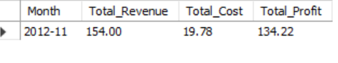
We used the call function to return a certain date from our store procedure which gave us the required result hence, our store procedure has been implemented and runs successfully.
When dealing with large datasets, complex transaction rules and for system security store procedures are used to efficiency, maintainability, data integrity and reliability improving the performance of RDBMS (Ling and Baohua, 2010).

Task 2.4: Chen Notation Diagram

Furthermore, we will create an ER diagram using Chen’s notation. A Chen’s notation diagram is an earlier form of entity relationship diagram where rectangles are used to represent entities and diamond shapes used to present relationships. We will create a conceptual Chen’s notation diagram to showcase how new value can be created for customers and vendors through personalized recommendation.
In this diagram we will not create all the entities created in our original ER diagram but the once necessary to showcase the relevant relationships within our database to support our new personalized recommendation table. Below you will see our Chen’s notation diagram and moreover, we will explain how personalized recommendation can help create value for customers and vendors.

Figure 17: Chen’s Notation Diagram
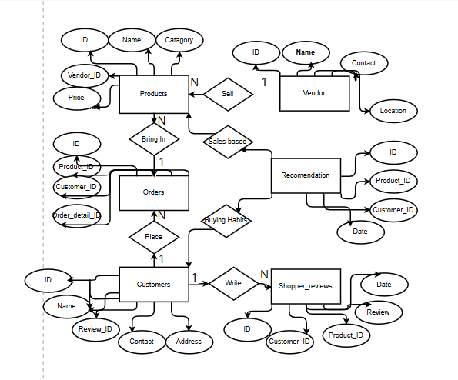

Personalized recommendation can be done by using customer previous purchases, their reviews and their buying habits to suggest them product that they may like.
It can also value vendors by using the same data to recommend vendor which of their products are most bought by customers and which are least bough so that they may stock up the in-demand product or give discount on least bought to increase sales.

Task 3: Theoretical Discussion

Task 3.1: Query Optimization

Furthermore, we will take the query we used to find the ‘Most profitable vendor’ and discuss how we optimized that query and discuss how long does it take to run such a query on different sizes of data.
Figure 18: Query to find most profitable Vendor
This query for us performed very well and gave us our required results in an instant, what we did to optimized this query was that due to our data tables being normalized we were able to use ‘Join’ functions that speeded up our process with this the system is not required to scan thousands of records but by using Join it will only fetch the required data reducing unnecessary excessive scanning and similar benefits were gained when we used the Order by, Limit 1 function, again unnecessary scanning was reduced the system stopped scanning after the first result again increasing speed of the system.
But then again, our database was small when dealing with very large datasets it may have taken more time to process our query. For solve this, techniques such as indexing the most used columns can be implemented, large tables can be partitioned into smaller once this would improve query performance, storing pre-computed aggregated values in separate columns can help, etc. to improve query performance in very large data sets.

Task 3.2: ACID Properties

Furthermore, we will discuss the ACID properties guaranteed by relational database management systems such as MySQL and we shall give examples of ACID properties in our marketplace scenario.
ACID properties stand for Atomicity, Consistency, Isolation and Durability.
Atomicity meaning it’s all or nothing either the transaction will be performed fully if it breaks at any point the entire transaction will be reverted. This help in our online store in the instance money is deducted from the customer account when he bough an item but in case of system failure or that item being already sold out the money will be returned to that customer.
Consistency meaning ensuring that the data is consistence and valid across all tables, this helps in linking the products to the correct vendor, orders to their correct order details, etc.
Isolation avoids concurrent transaction in the case that the transaction is only possible once, for example if two customers try to buy the same item which is the last in stock both of the transaction will not happen simultaneously by only one will pass through and for the other customer the item will be shown out of stock.
Durability means saving the performed transaction even if the system crashes half way the transaction can be completed were it was left off, for example if the customer adds up few items in his cart and the system crashes in the back end a log is kept of his cart and the customer can resuming were he left off.
In a distributed database it is important that the distributed data is valid across all users to address this issue ACID properties are used this guarantee’s reliability of the database transactions (Yu, 2009).

Task 3.3: CAP Theorem

Furthermore, we will discuss the CAP theorem, CAP stands for Consistency, Availability and Partition tolerance. As per the CAP theorem all these three characteristics cannot exist together for a distributed database you can either get consistency and availability or availability and scalability or consistency and scalability.
Consistency ensures that all the data across the database is valid and the transaction performed are up to date however, this may reduce the performance speed of the system reducing availability.
Availability ensures that is times of very high traffic the system does not lag or become slower however, consistency may be affected as it can take up longer time that the system cannot expend.
And then we have Partition tolerance where scalability is prioritized meaning a very larger data set which may take up more processing power hence, sometimes consistency has to be given up.
CAP theorem is an example of a general tradeoff between safety and liveness in unreliable systems. It provides insight into the inherent tradeoffs and the manner in which they can be circumvented in practice (Gilbert and Lynch, 2012).

Task 3.4: Case Study

Furthermore, we will look at a case study of an analytical data warehouse used by a e-commerce company to answer few simple questions:
- What technology is used in the data warehouse?
- Why were this technology chosen?
- What use case is particularly important for the company?
- What management consideration must be taken into account when managing the companies database?
The case study we will be discussing will be Amazon’s e commerce business to address the questions stated above, we have taken the data from “Data Forest Blog” a well reputable site.
As we all know that Amazon is the world largest e-commerce platform hence, they have faced my challenges in managing the technology for establishing their e commerce system.
Amazon uses their own developed technology for data warehousing, creating data pipeline, data processing and data security. Amazon uses Amazon Redshift a distributed data warehouse architecture which can be used to store petabytes of data, Amazon uses AWS pipelines and AWS Glue to automate the movement, collection and transformation of vast amount of data, having a fully managed ETL service.
Amazon uses AWS S3 for storing unstructured data, Elastic map reduce for batch processing, lambda for real time processing. And for data security Amazon uses systems such as AWS-KMS ensuring data privacy, AWS-IAM to limit and manage user access and Macie which uses machine learning to classify and protect sensitive data.
The reason for Amazon to develop their own technology was to save cost because Amazon had become so large that best approach was to develop their own system to handle, grow and keep their e-commerce system safe by themselves, this saved them tremendous cost in managing their data warehouse.
One of the most important use cases for Amazon is to optimize product recommendation and personalize the shopping experience for customers for which they use machine learning systems implemented using Lambda or S3 to boost their sales and in return earn more profits.
And as stated above AWS-IAM is used to limit and manage user access and based on the management roles and internal stake holder privilege i-e cooperate position, the data access is granted.

CONCLUDING REMARKS

We have demonstrated our skills to establishing a relational database from grounds up, we discussed each step, explained the key concepts, argued the use cases and practical implemented these steps in creating our database using MySQL.
From creating the ER diagram, creating table, data normalization, importing data, creating triggers, running different SQL queries, creating store procedure, we had theoretical discussions, etc.
Although our store is running smoothly at the moment however, as per the CAP theorem we are destined to face difficulties once the online store scales and large data would be collected and processed hence, for scalability we might need to give up consistency, which is of key importance specially in an e-commerce business where data validity across all systems is crucial. Hence, there is a possibility that we might need to move or incorporate other data warehousing systems such as NoSQL system or Big Data solutions.

BIBLIOGRAPHY

Kofler, M., 2001. What Is MySQL?. In The Definitive Guide to MySQL (pp. 3-19). Berkeley, CA: Apress.
Mohammed, M.A., Muhammed, D.A. and Abdullah, J.M., 2015. Practical Approaches of Transforming ER Diagram into Tables. International Journal of Multidisciplinary and Scientific Emerging Research, 4(22), pp.2349-6037.
Cleve, A. and Hainaut, J.L., 2012, October. What Do Foreign Keys Actually Mean?. In 2012 19th Working Conference on Reverse Engineering (pp. 299-307). IEEE.

de Brock, B., 2023, July. Managing Database Trigger Design. In International Symposium on Business Modeling and Software Design (pp. 352-364). Cham: Springer Nature Switzerland.

Rockoff, L., 2021. The language of SQL. Addison-Wesley Professional.
Baohua, T. and Ling, Z., 2010, June. A performance optimization based on stored procedure in RDBS project. In 2010 International conference on computer and communication technologies in agriculture engineering (Vol. 3, pp. 594-597). IEEE.
Yu, S., 2009. Acid properties in distributed databases. Advanced eBusiness Transactions for B2B-Collaborations, p.17.
Gilbert, S. and Lynch, N., 2012. Perspectives on the CAP Theorem. Computer, 45(2), pp.30-36.

